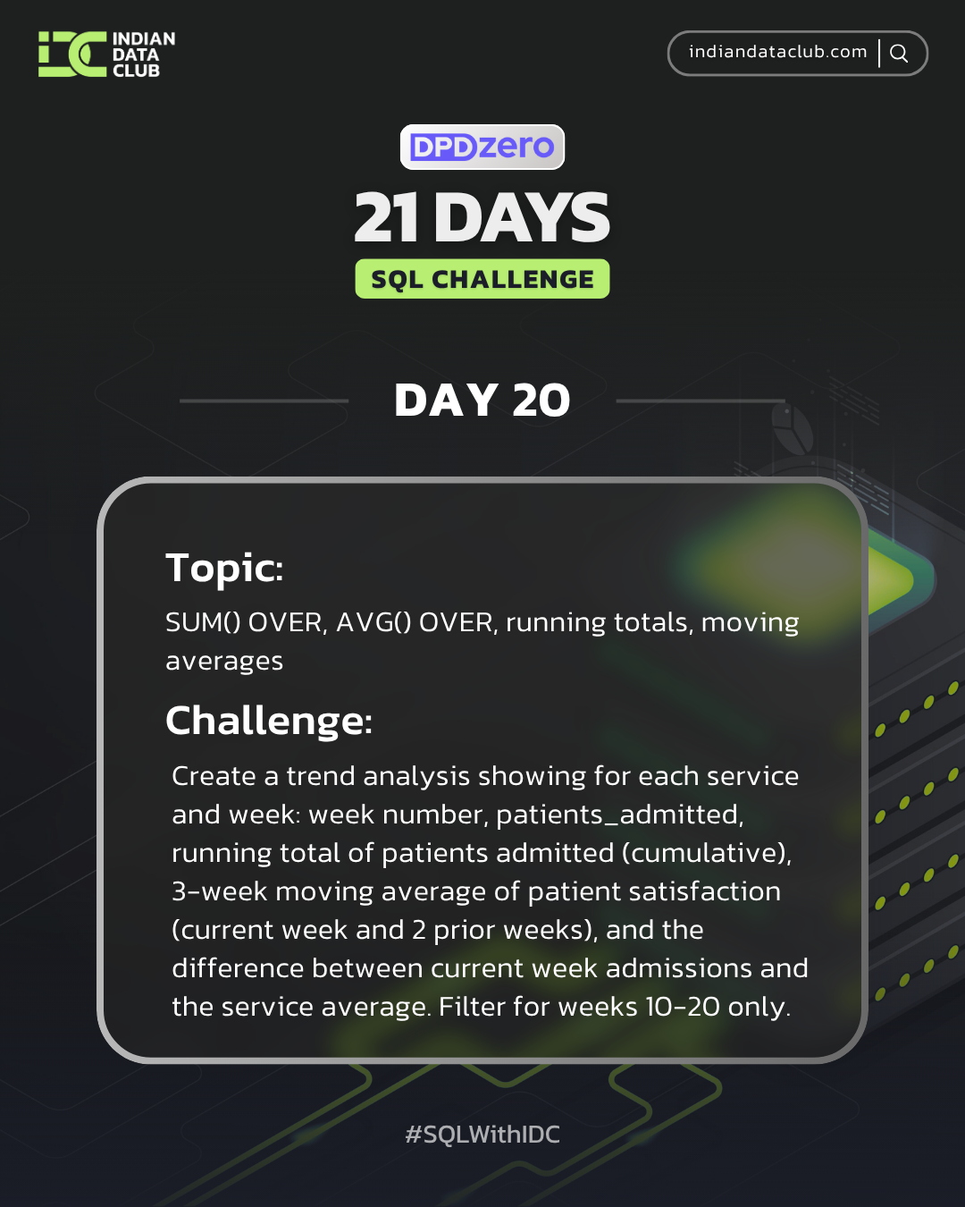
Day-20 SQL Challenge
Day-20 Challenge:
Create a trend analysis showing for each service and week: week number, patients_admitted, running total of patients admitted (cumulative), 3-week moving average of patient satisfaction (current week and 2 prior weeks), and the difference between current week admissions and the service average. Filter for weeks 10-20 only.
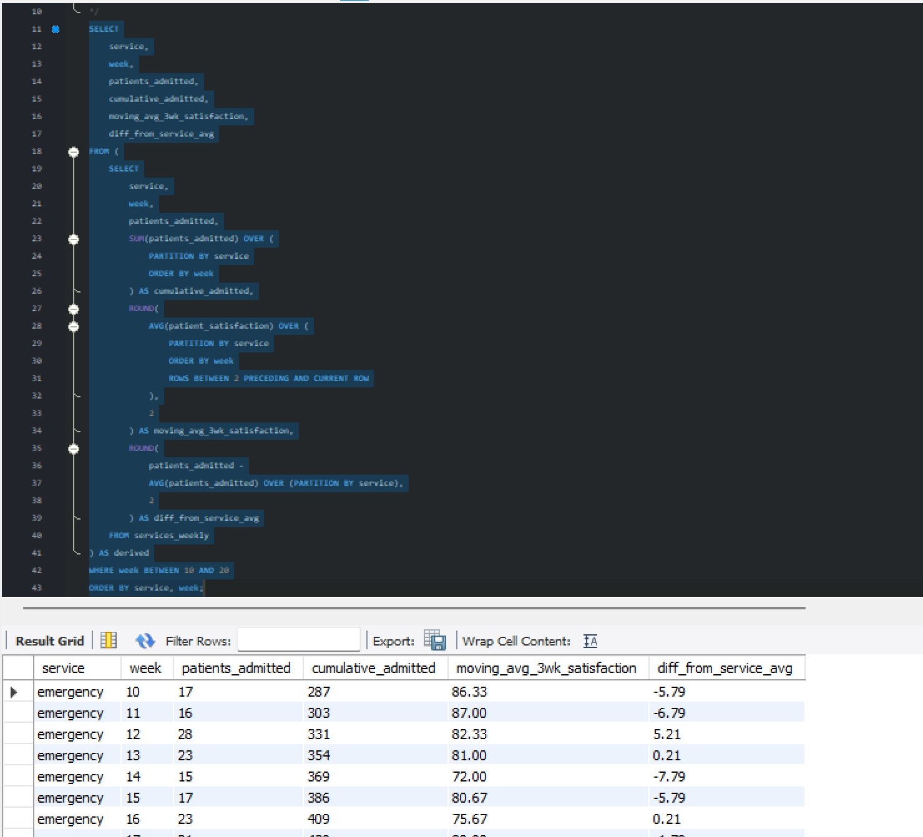

Practice Questions:
1. Calculate running total of patients admitted by week for each service.
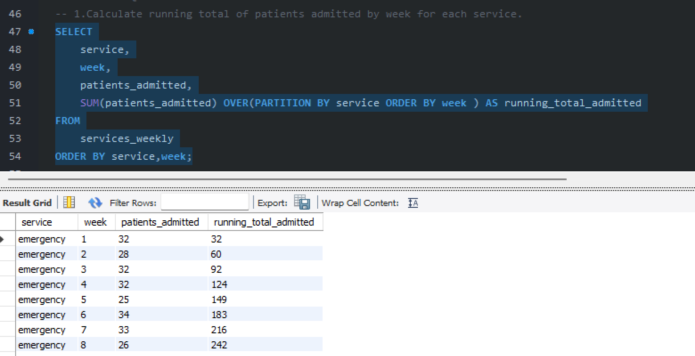

2. Find the moving average of patient satisfaction over 4-week periods.
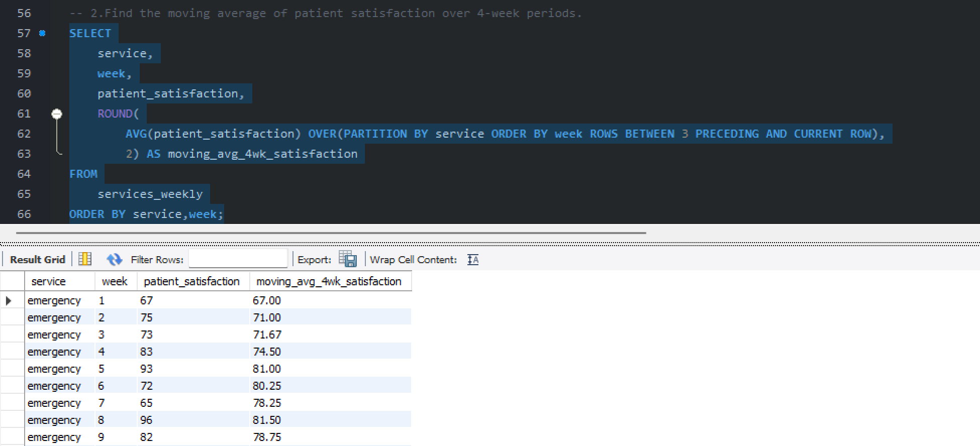

3. Show cumulative patient refusals by week across all services.
